FORENSIC MEDICAL EXAMINATION REPORT
Blunt Force Trauma & Radiological Injury Documentation
Case No: KRP-2025-0309-CL03 | Kerala State Police — Ernakulam District
1. CASE IDENTIFICATION

Case Reference | KRP-2025-0309-CL03
Incident Title | Physical Assault — College Parking Area, Kochi
Reporting Authority | Ernakulam District Police, Kerala
Date of Incident | 9 March 2025
Time of Incident | Approximately 5:20 PM IST
Location | College parking lot, Ernakulam, Kerala
Date of Examination | 9 March 2025 (same day, emergency department referral)
Examining Physician | Dr. [Name Withheld for Demo Purposes]
Designation | Medical Officer / Forensic Examiner, Govt. Medical College, Ernakulam

2. VICTIM PARTICULARS

Full Name | Student — [Name Withheld — Demo]
Age | Approximately 19–22 Years (College Student)
Gender | Male
Role in Incident | Victim of Physical Assault
Alleged Assailant | Fellow College Student (identity under investigation)
Reported By | College security personnel and bystanders
Brought To | Government Medical College Emergency Department, Ernakulam
Mode of Arrival | Ambulance, accompanied by campus security
GCS on Arrival | 15/15 — Conscious and oriented

3. HISTORY & PRESENTING COMPLAINT
The victim presented with complaints of pain over the left lateral chest wall, tenderness on breathing, and swelling with discolouration over the left arm following a physical altercation at the college parking area at approximately 5:20 PM on 9 March 2025.
Per collateral history provided by witnesses, the victim was involved in a verbal dispute with a fellow student which escalated into a physical confrontation. The alleged assailant delivered multiple punching blows directed at the left upper body, followed by a kick to the left lateral chest. The victim was found on the ground by security personnel approximately 5 minutes after the altercation.
No loss of consciousness reported. No vomiting, haemoptysis, or haematemesis. Shortness of breath noted on exertion. Tenderness and swelling progressively worsened over 30 minutes prior to arrival.

4. EXTERNAL EXAMINATION & INJURY DOCUMENTATION
General appearance: Alert, oriented, in moderate distress. Vital signs at admission — BP: 118/76 mmHg, Pulse: 96 bpm, RR: 22 breaths/min (mildly tachypnoeic), SpO2: 96% on room air.
Systematic external examination revealed two distinct injury sites documented below.

4a. Injury Site 1 — Left Upper Limb Contusion (Exhibit FME-01)
Injury Type | Blunt force contusion (bruise) — non-incised, no laceration
Location | Anterolateral aspect of the left arm, mid-humeral region
Dimensions | Approximately 9 cm × 5 cm (largest extent)
Colour | Confluent purple-blue centrally with yellow-green periphery — indicative of bruise aged 24–72 hours in standard ageing, but given acute presentation, colour variation may reflect tissue depth and vessel calibre
Pattern | Irregular, multi-lobulated — consistent with repeated blunt impacts from a fist or shod foot
Tenderness | Marked; voluntary guarding on palpation
Swelling | Moderate soft tissue swelling; no crepitus; neurovascular status intact distal to injury
Skin Integrity | Intact — no abrasions or lacerations overlying the bruise
Bruise Age Estimate | Coloration pattern (purple-blue central, yellow peripheral) suggests this is a single-episode acute impact with subcutaneous layering of haemorrhage — consistent with stated time of injury

Figure 1: Left Upper Limb Contusion — Exhibit FME-01
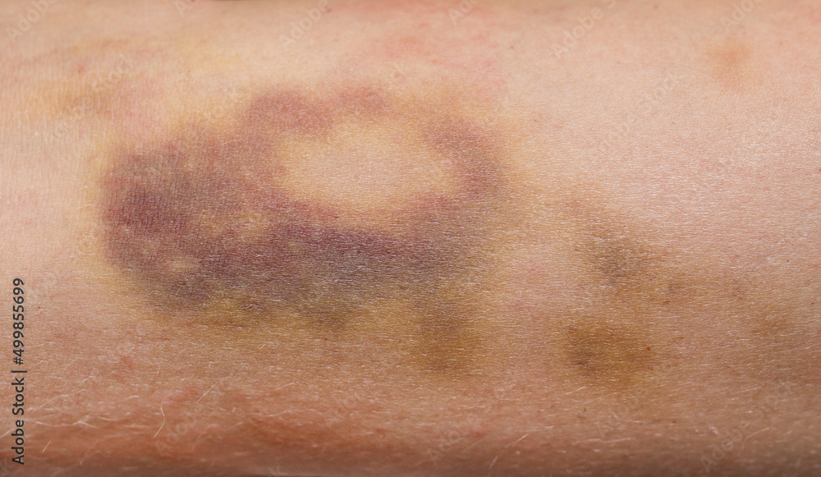
Exhibit FME-01 | Photographed on admission: 09/03/2025, 6:05 PM IST | Left arm, anterolateral view

4b. Injury Site 2 — Left Lateral Chest Wall Tenderness / Radiological Findings (Exhibit FME-02)
Examination of the chest wall revealed marked tenderness on palpation over the left lateral ribs (7th–9th), with mild visible swelling and ecchymosis developing at the skin surface. Respiratory excursion was reduced on the left side. Breath sounds were slightly diminished at the left base. No paradoxical movement noted (no flail segment).
Chest X-ray (PA view) was obtained and is documented below as Exhibit FME-02. The red ellipse annotation on the radiograph marks the region of pathological interest identified by the radiologist on call.

Radiograph Type | Chest X-Ray — Postero-Anterior (PA) View
Side Affected | Left lateral chest wall (annotated with red ellipse)
Radiological Findings | Cortical discontinuity of the left 8th and 9th ribs in the mid-axillary line — consistent with acute rib fractures
Lung Fields | Left lower lobe shows increased opacity consistent with early contusion or haematoma; no frank pneumothorax identified on plain film
Mediastinum | Midline; no widening; cardiac silhouette normal
Clinical Correlation | Findings consistent with blunt chest trauma — rib fractures 8th and 9th left with probable pulmonary contusion
Further Imaging | CT Chest recommended for definitive evaluation of pneumothorax, haemothorax, or parenchymal injury

Figure 2: Chest X-Ray (PA View) Showing Left Rib Fractures — Exhibit FME-02
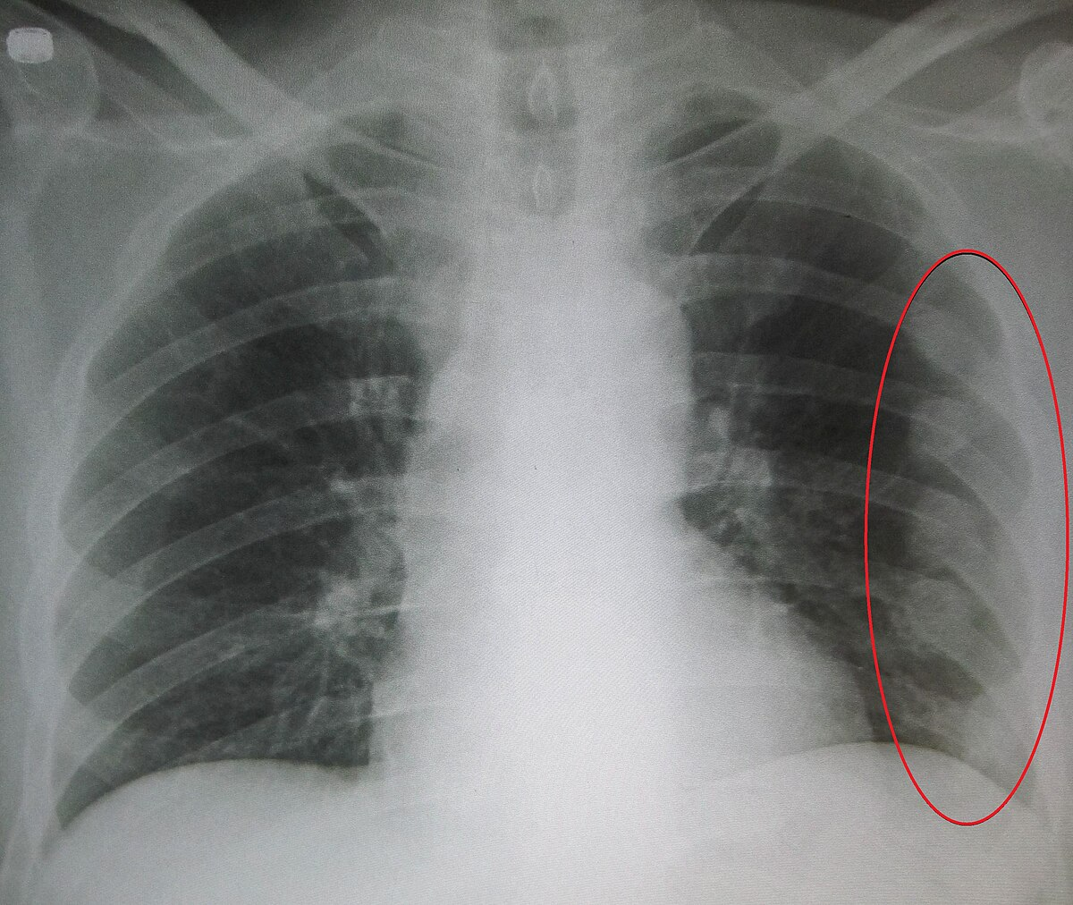
Exhibit FME-02 | X-Ray taken: 09/03/2025, 6:28 PM IST | Red ellipse: Left 8th–9th rib fracture zone, mid-axillary line

5. SUMMARY OF INJURIES

# | Injury | Location | Severity | Exhibit
1 | Blunt force contusion | Left arm, anterolateral, mid-humeral | Moderate | FME-01
2 | Rib fractures (8th & 9th, left) with probable pulmonary contusion | Left lateral chest wall, mid-axillary line | Serious | FME-02

6. INJURY CAUSATION & FORENSIC ANALYSIS
- Both injuries are consistent with blunt force trauma inflicted by a human fist and/or shod foot — no sharp force component identified.
- The arm contusion pattern (multi-lobulated, ~9×5 cm) is consistent with repeated punch impacts rather than a single blow — indicating sustained assault.
- Fracture of ribs 8 and 9 (left) requires significant force — inconsistent with a minor shove or incidental contact. A lateral kick or stamping impact is the most plausible mechanism.
- Absence of defensive injuries on the forearms suggests the victim may not have anticipated the attack, or was restrained/pushed prior to the chest impact.
- All injuries are ante-mortem and consistent with the stated time and mechanism of injury. Findings support the witness accounts of a physical assault involving punching and kicking.
7. TREATMENT INSTITUTED
The following emergency management was initiated upon admission:
- IV access secured; analgesia administered (IV paracetamol 1g + morphine 4mg titrated).
- Supplemental oxygen via nasal cannula at 2 L/min; SpO2 improved to 99% within 20 minutes.
- Chest X-ray performed and interpreted — rib fractures confirmed; CT chest ordered for definitive haemothorax/pneumothorax exclusion.
- Left arm X-ray performed — no bony injury to the humerus or radius identified; soft tissue haematoma confirmed.
- Patient admitted to surgical ward for observation; surgical review requested pending CT results.
8. MEDICO-LEGAL OPINION
1. The injuries documented — left arm contusion and left 8th–9th rib fractures with probable pulmonary contusion — are caused by blunt force trauma and are consistent with the alleged assault by punching and kicking.
2. The nature and distribution of injuries are not self-inflicted and are not consistent with a simple fall.
3. The rib fractures with associated pulmonary changes constitute a 'grievous hurt' as defined under Section 320 of the Indian Penal Code (now BNS Section 116), specifically: 'fracture or dislocation of a bone or tooth.'
4. The contusion to the left arm constitutes 'simple hurt' under BNS Section 115.
5. The degree of force required to fracture two ribs is substantial, indicating that the assault was not minor in nature. The possibility of life-threatening complications (haemothorax, pneumothorax) cannot be excluded until CT results are available.
6. This report is issued for medico-legal purposes and may be used as evidence in any criminal proceedings arising from this incident.

9. CERTIFICATION
I, the undersigned, certify that this report reflects my clinical and forensic findings on examination of the victim to the best of my knowledge and professional judgment, and that the injuries documented are consistent with the alleged assault as described.

Examining Physician:  Dr. [Name Withheld — Demo]  Medical Officer / Forensic Examiner  Govt. Medical College, Ernakulam  Reg. No: MCI/KER/[DEMO] | Countersigned:  [Investigating Officer Name]  Sub-Inspector of Police  Ernakulam North Police Station  Badge No: [DEMO]

⚠ THIS IS A DEMONSTRATION DOCUMENT GENERATED FOR CASE ILLUSTRATION PURPOSES ONLY ⚠

